

**Class :-12th Science Information Technology Teacher : Mrs. Shilpa Kate**

**Exercise solution: Lesson No.5. PHP**

### Q1 Fill in the blanks.

1.PHP is **Server** side scripting side language.

2. PHP is **interpreted** LANGUAGE i.e. there is no need of compilation.

3. A variable starts with **$** sign followed by variable name.

4. An **array** is a variable, which can hold more than one value at a time.

5. Information can be passed to functions through **arguments**

**Q2 State whether given statement is true or false.**

1.PHP is platform dependent scripting language.

**Ans: False**

**2.** $_POST is an array of variables PASSED VIA the URL PARAMETERS.

**Ans: False**

1. A Function is a block of statements that can be used repeatedly in a program.

**Ans: True**

4.PHP cannot be embeded along with HTML tags.

**Ans:False**

5.GET should NEVER be used for sending sensitive information.

**Ans:True**

### Multiple choice questions. Select one correct answer.

* 1. The program file of PHP have____________ extension.
     1. .asp **b) .php**

c) .js d) .txt

2. A variable declared a function has global scope.

* + 1. **outside** b) anywhere

c) inside d) none

3. The function returns a part of a string.

* + 1. trim() b) ucwords()

**c) substr()** d) strpos()

### Q4. Multiple Choice Question. (2 correct)

1. The & are valid datatype in PHP.
   1. Double b) Varchar

**c) Integer d) Array**

e) BigInt

1. Single line comment in PHP is possible using , .

**a) // b) /* */**

c) # d) <! >

e) $

### Q5. Multiple Choice Question. (3 correct)

1. In PHP, three types of arrays are

, , .

* 1. **Indexed** b) Simple

1. **Associative**
2. **Multidimensional**
3. Complex f) General

2. The scope of variable can be _____________.

* 1. **local** **b) global**

c) universal **d) static**

e) final f) outside

### Q6. Brief Questions.

**1.)Explain any two features of PHP?**

Ans:

Simple: It is very simple and easy to use as compared to other scripting languages.

Interpreted: It is an interpreted language i.e no need of compilation.

Faster: It is faster than other scripting language e.g JSP & ASP

Open Source: It means you will not pay money to use it .You can freely download and use it.

Platform Independent: It will run on all platform like Linux, Unix, Mac OS, Windows.

Case Sensitive: It is case sensitive when you declare variables.

All keywords(echo , if, else etc) ,classes, functions and user-defined functions are not case-sensitive.

Error Reporting: PHP has some pre-defined error reporting constants to generate a warning or error notice.

**2)What are the rules to declare variable in PHP?**

Ans:

* Variable starts with $ sign, followed by name of the variable.
* A variable name must start with a letter or underscore character.
* A variable name cannot start with a number.
* A variable name can only contain alpha-numeric characters and underscores(A- z,0-9 and _[underscore]) .
* Variable names are case-sensitive. (Eg. $age and $AGE are considered different).

**3.What is server side scripting?**

Ans::

* A server is a computer system that serves as a central repository of data and programs and is shared by all clients.
* The server side environment that runs a scripting language is termed as web server.
* Server-side scripting as it relates to web pages usually refers to PHP code that is executed on the web server before the data is passed to the user's browser.

**4).List the supported datatypes in PHP.**

Ans: PHP can store data of different types and PHP supports following data types:

* + String
  + Integer
  + Float
  + Boolean
  + Array
  + NULL

**5.)Explain any two string manipulation function**

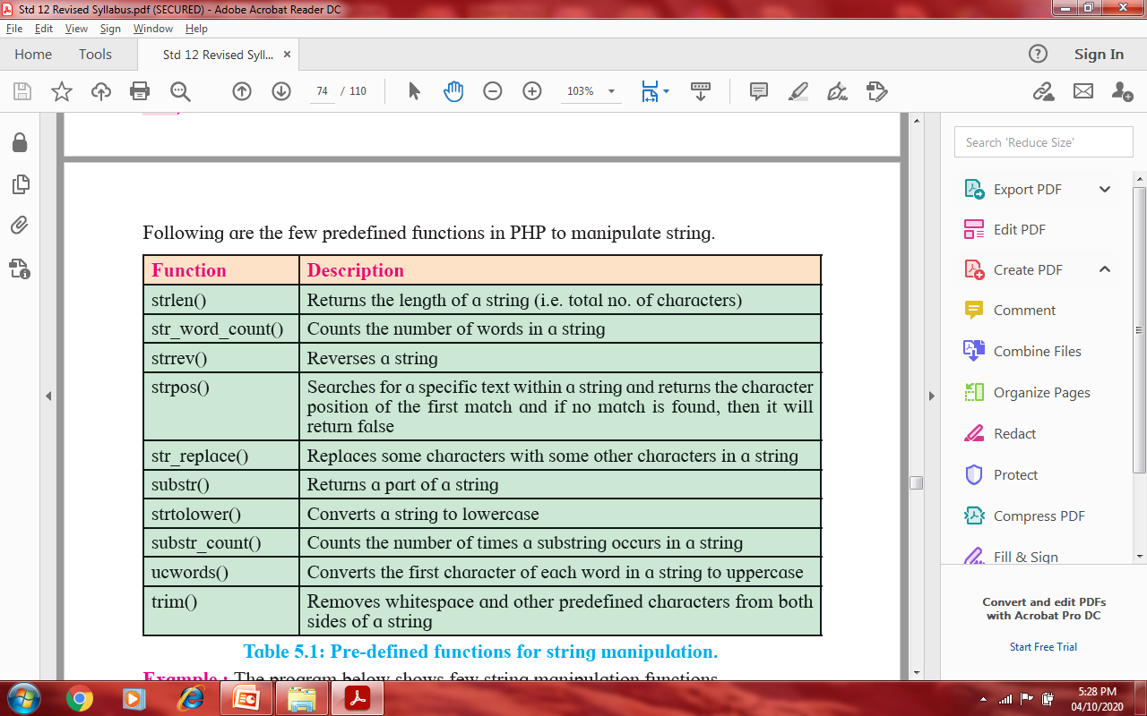

### Q.7 Write event driven JavaScript program for the following.

1. **Write a PHP code which calculates square of any number using form**

1.php

<html>

<body>

<form method="post" action="cube.php">

Enter no<input type="text" name="t1"><br><br>

<input type="submit" name="submit" value="cube">

</form>

</body>

</html>

*****************cube.php*****************

<?php

$sq=$_POST['t1'];

$s=$sq*$sq*$sq;

echo"<br> The cube is".$s;

?>

1. **Write a PHP code to count no. of words in the given string.**

Ans:: /* Write A PHP code to count no. of words in the given string.*/

<?PHP

$a= "Hypertext Preprocessor";

echo"<br><br> String is".$a;

echo"<br><br> Words is string is".str_word_count($a);

?>

1. **Create a website with two PHP webpage in which each webpage is connected.**

**The first page of the website contains two form fields for taking ‘name’ and ‘password’ from users. On onclick event, details of forms should be displayed on second webpage**

Ans:: form.html

<html>

<body>

<form action=”wc.php” method=”post”>

Enter Name:

<input type=”text” name=”name”><br><br>

Enter Password:

<input type=”password” name=”pass”><br><br>

<input type=”submit” name=”submit” value=”submit”>

</form>

</body>

</html>

*****Wc.php******

<?php

Echo "Username is ::".$_POST["name"];

Echo"<br>Your Password is:";

Echo $_POST["pass"];

?>